A cell (r, c) of an excel sheet is represented as a string "<col><row>" where:

* <col> denotes the column number c of the cell. It is represented by **alphabetical letters**.
  + For example, the 1st column is denoted by 'A', the 2nd by 'B', the 3rd by 'C', and so on.
* <row> is the row number r of the cell. The rth row is represented by the **integer** r.

You are given a string s in the format "<col1><row1>:<col2><row2>", where <col1> represents the column c1, <row1> represents the row r1, <col2> represents the column c2, and <row2> represents the row r2, such that r1 <= r2 and c1 <= c2.

Return *the****list of cells*** (x, y) *such that* r1 <= x <= r2 *and* c1 <= y <= c2. The cells should be represented as **strings** in the format mentioned above and be sorted in **non-decreasing** order first by columns and then by rows.

**Example 1:**

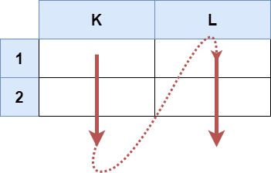

**Input:** s = "K1:L2"

**Output:** ["K1","K2","L1","L2"]

**Explanation:**

The above diagram shows the cells which should be present in the list.

The red arrows denote the order in which the cells should be presented.

**Example 2:**

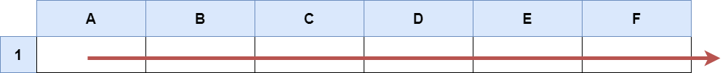

**Input:** s = "A1:F1"

**Output:** ["A1","B1","C1","D1","E1","F1"]

**Explanation:**

The above diagram shows the cells which should be present in the list.

The red arrow denotes the order in which the cells should be presented.

**Constraints:**

* s.length == 5
* 'A' <= s[0] <= s[3] <= 'Z'
* '1' <= s[1] <= s[4] <= '9'
* s consists of uppercase English letters, digits and ':'.